
Facilities

BRS Golf Facility Booking Module
You will find the new module on your main menu under Facilities.

To add a new booking

- Click in the space under Reservation Name and enter a name for your booking.
- Enter the expected number of guests
- Select which Room/Facility to book
- Choose the Start and End times (approximately)
- For multiple day or repeat weekly bookings, you can use the Days and Weeks options, otherwise for one off bookings keep these both at 01.
- At the top of the page, click ‘Add’ to save your booking, or Cancel to not save it.

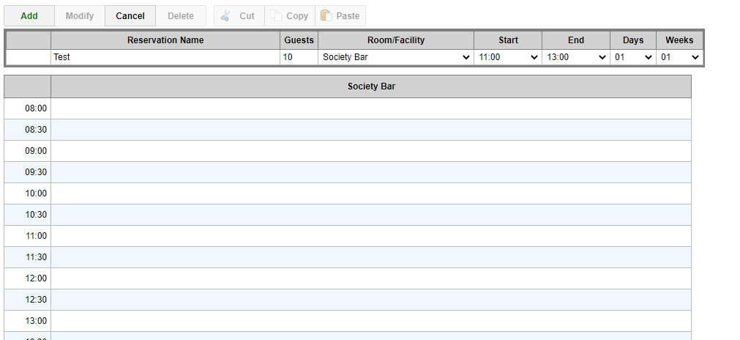

A confirmation message will appear, confirming the details of the booking
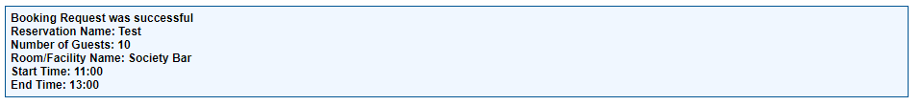

Add booking details
- Go to the date of the booking
- Click on the reservation name hyperlink to open the booking details screen.
- Enter any details for the booking, also print or email the details from here.
- Update
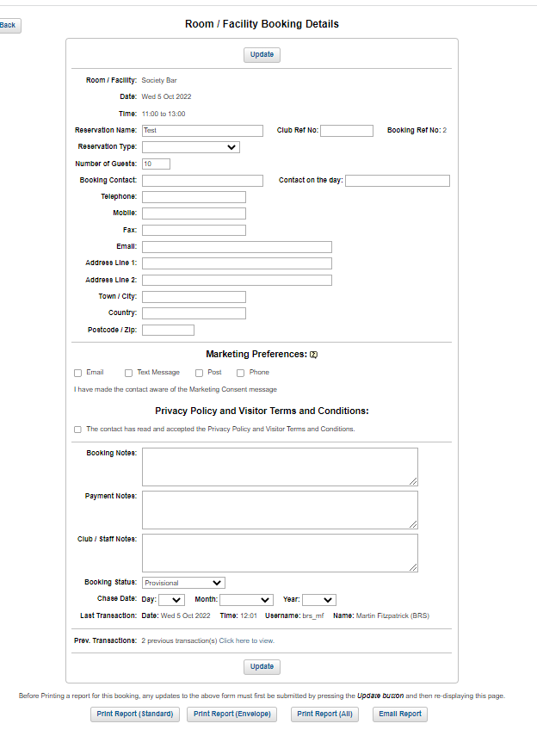

Amend /delete a booking
- Go to the date of the booking.
- Click on the radio button
- The Modify, Delete, Cut and Copy functions become available to use.
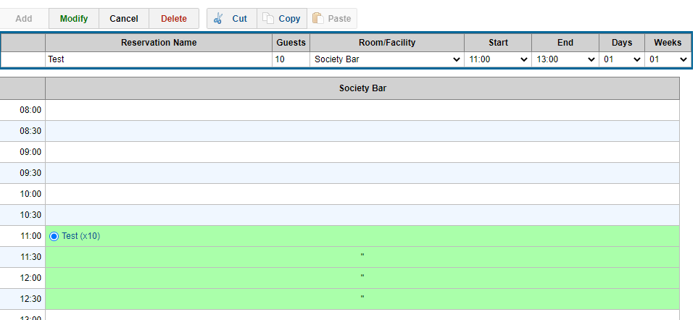

To Cut/move a booking

- After selecting your booking, click Cut
- Now go to the day you want to MOVE the booking to, select the room, start time and end time and then click the PASTE button.

To Copy a booking

- If you wish to make a duplicate COPY of a booking
- After selecting your booking, click COPY
- Go to the day you want to COPY the booking to, select the room, start time and end time and then click the PASTE button.

Reports

Within the Reports section, scroll to the end of the report names where several useful reports will now be available on the Facilities module.

